Tugas ke : 3

Mata Kuliah : Prak. Algoritma dan Pemrograman C++

**TUGAS PRAKTIKUM**



**Disusun Oleh :**

### NAMA : Moch Achmar

**STB : 222362**

**KELAS : J**

# UNIV1ERS1TAS DIPA MAKASSAR

**MAKASSAR**

**2022**

**Tugas :**

1. Buat program menghitung nilai y

Jawaban :

**// y = x³ - 3x² + 2x - 1**

**#include <iostream>**

**#include <math.h>**

**#include <conio.h>**

**using namespace std;**

**int x, y;**

**int main(){**

**cout << "|------------------------------------------------------------------|\n";**

**cout <<"|\t\t\t\tTUGAS PRAKTIKUM\t\t\t |" << "\n";**

**cout << "|\t\t\t Created By Moch Achmar\t\t |";**

**cout << "\n|------------------------------------------------------------------|\n";**

**cout << "\t\t\t Masukkan nilai x = ";**

**cin >> x;**

**y = pow (x, 3) - 3 * pow (x, 2) + 2 * (x) - 1;**

**cout << "|------------------------------------------------------------------|\n";**

**cout << "\t\t\t\tJadi nilai y = " << y << endl;**

**cout << "|------------------------------------------------------------------|";**

**getch();**

**}**

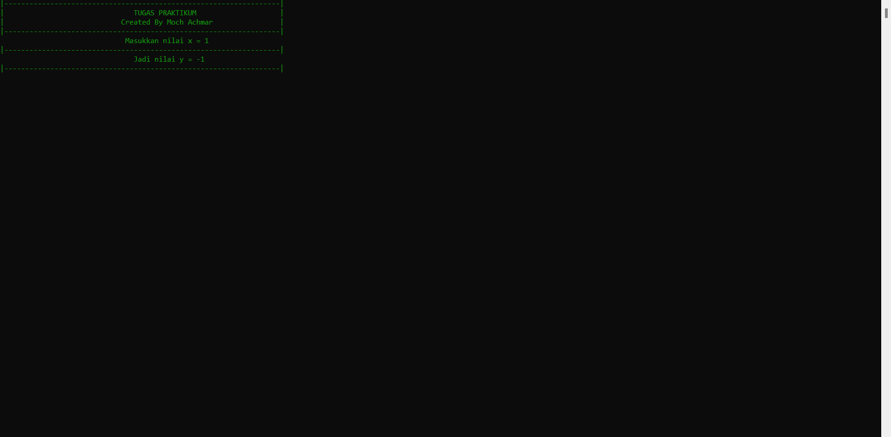

Hal : __

1. Sebuah gelas A warna merah, gelas B warna biru. Bagaimanakah caranya jika gelas A warna biru dan gelas B warna merah?

Jawaban :

**#include <iostream>**

**#include <conio.h>**

**using namespace std;**

**string a = "Merah";**

**string b = "Biru";**

**string c;**

**int main () {**

**cout << "|------------------------------------------------------------------|\n";**

**cout <<"|\t\t\t\tTUGAS PRAKTIKUM\t\t\t |" << "\n";**

**cout << "|\t\t\t Created By Moch Achmar\t\t |";**

**cout << "\n|------------------------------------------------------------------|\n";**

**cout << "\t\t\t\tGelas A = " << a << endl;**

**cout << "\t\t\t\tGelas B = " << b << endl;**

**c = a;**

**a = b;**

**b = c;**

**cout << "|------------------------------------------------------------------|";**

**cout << "\n\t\t\tWarna pada gelas A adalah " << a << endl;**

**cout << "\t\t\tWarna pada gelas B adalah " << b << endl;**

**cout << "|------------------------------------------------------------------|";**

**getch();**

**}**

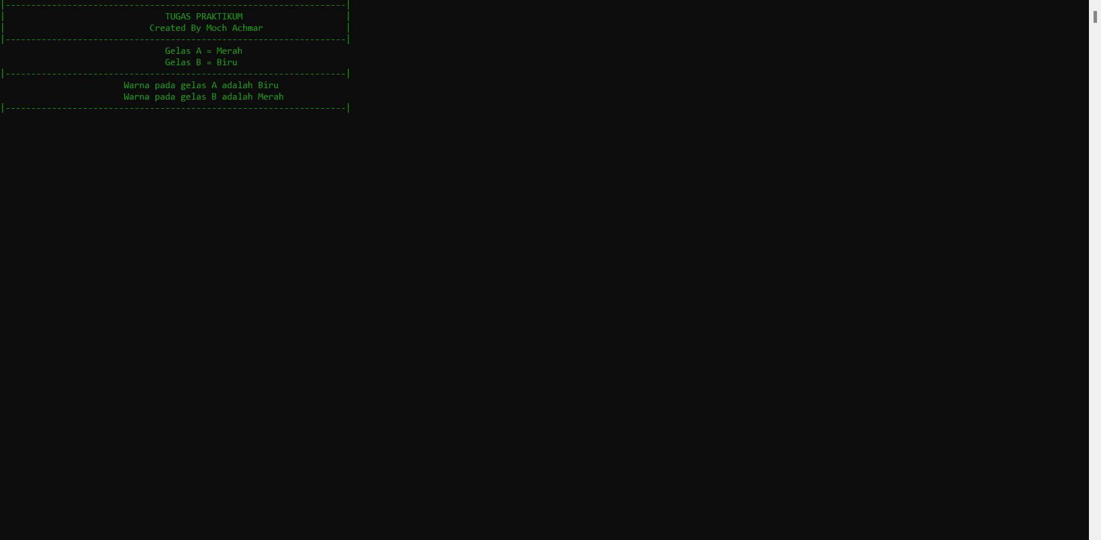

Hal : __

1. Sebuah gelas 1 berisi 5 liter air, gelas 2 berisi 3 liter air, bagaimanakah cara mendapatkan air 2 liter dan 4 liter.

Jawaban :

**// Gelas 1 = 5 liter**

**// Gelas 2 = 3 liter**

**// 1. cara mendapatkan air 2 liter**

**// 2. cara mendapatkan air 4 liter**

**#include <iostream>**

**#include <conio.h>**

**using namespace std;**

**int ember_1, ember_2;**

**int const a = 5;**

**int const b = 3;**

**int main (){**

**cout << "|------------------------------------------------------------------|\n";**

**cout <<"|\t\t\t\tTUGAS PRAKTIKUM\t\t\t |" << "\n";**

**cout << "|\t\t\t Created By Moch Achmar\t\t |";**

**cout << "\n|------------------------------------------------------------------|\n";**

**cout << "|\t\t\t\tGelas 1 = " << a << " liter\t\t |" << endl;**

**cout << "|\t\t\t\tGelas 2 = " << b << " liter\t\t |" << endl;**

**// 2**

**ember_2 = 3; // Isi penuh ember 2 dengan 3 liter air**

**ember_1 = ember_2; // tuang ember 2 ke ember 1**

**ember_2 = 3; // isi kembali ember 2 dengan 3 liter air**

**ember_1 = ember_1 + ember_2 - 1; // tuang ember 2 ke ember 1, jadi ember 1 sekarang 5 liter air**

**ember_2 = 1; // ember 2 sisa 1 liter air**

**ember_2 = ember_2 + 1; // isi ember 2 dengan 2 liter air, jadi ember 2 menjadi 3 liter air**

**ember_1 = 0; // buang semua air di ember 1, jadi ember 1 jadi kosong**

**ember_1 = ember_2 - 1; // tuang 2 liter ember 2 ke ember 1, jadi ember 1 jadi 2 liter**

**ember_2 = 1; // ember 2 jadi 1 liter air)**

**ember_2 = 0; // buang semua air di ember 2, jadi ember 2 jadi kosong**

**ember_2 = ember_1; // tuang 1 liter ember 1 ke ember 2**

**ember_1 = ember_1 + ember_2; // ember 1 = 1 + 1 = 2;**

**cout << "|------------------------------------------------------------------|\n";**

**cout << "|\t\t 1. Air didalam ember 1 sebanyak "<< ember_1 << " liter" << "\t |" << endl;**

Hal : __

**// 4**

**ember_2 = 3; // Isi penuh ember 2 dengan 3 liter air**

**ember_1 = ember_2; // tuang ember 2 ke ember 1**

**ember_2 = 3; // isi kembali ember 2 dengan 3 liter air**

**ember_1 = ember_1 + ember_2 - 1; // tuang ember 2 ke ember 1, jadi ember 1 sekarang 5 liter air**

**ember_2 = 1; // ember 2 sisa 1 liter air**

**ember_1 = 0; // buang semua air di ember 1, jadi ember 1 jadi kosong**

**ember_1 = ember_2; // tuang ember 2 ke ember 1, jadi ember 1 menjadi 1 liter air**

**ember_2 = 3; // isi kembali ember 2 hingga penuh**

**ember_1 = ember_1 + ember_2; // ember 1 = 1 + 3 = 4;**

**cout << "|\t\t 2. Air didalam ember 2 sebanyak "<< ember_1 << " liter" << "\t |" << endl;**

**cout << "|------------------------------------------------------------------|";**

**getch();**

**}**

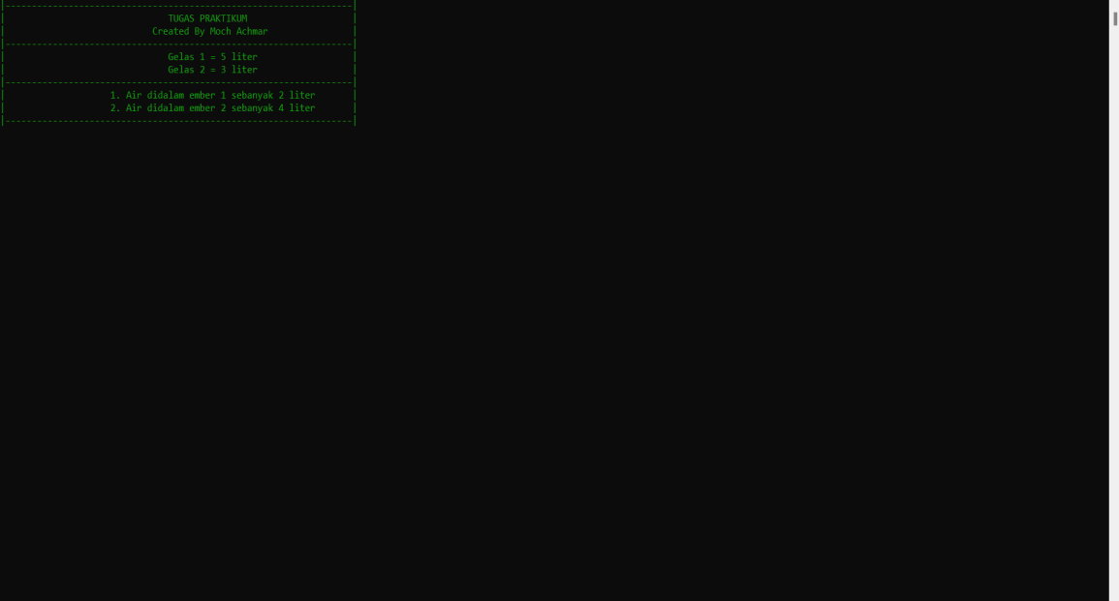

Hal : __